Group 9

Eric Garcia

Nathan Schapher

Eduardo Jimenez

1. Provide link to GitHub repository for TAs to view the code? (5 point)

* <https://github.com/Nate7204/4353Project>

1. List what backend technologies you are using and why? (2 points)

* We used the React.jwt authentication and Node Server.js. The main module that we used is Axios to make http requests for data and to maintain local storage.

1. Provide code coverage report. (3 points)
   * 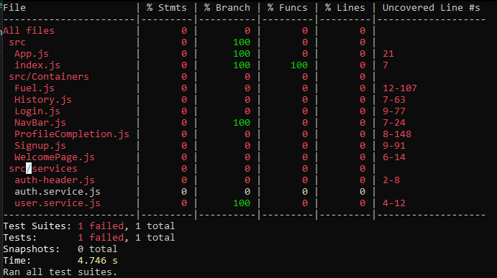\
2. **IMPORTANT: list who did what within the group. TAs should be able to validate in GitHub, otherwise team members who didn't contribute will receive a ZERO.**
   * Eric worked on the sign up and login portion of the backend, which would allow the user to be able to enter their accounts. Nathan worked on the fuel quote form, which accessed information from the backend to retrieve the data for the address. Eduardo worked on being able to send the profile information to the backend to be stored and later accessed again.